WorkHorse Frame BOM
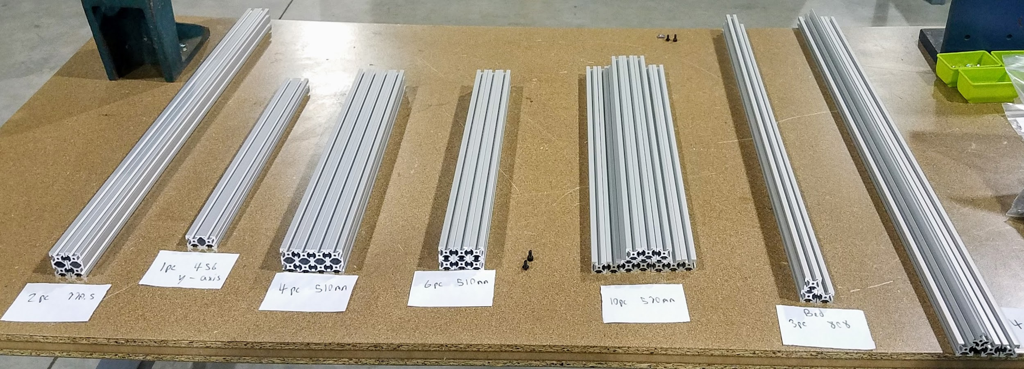

Frame Extrusions | Length | Units | Description | Part #
2020 | 930mm Long | 4pcs | Horizontals | HFS5-2020-930
2020 | 510mm Long | 6pcs | Verticals | HFS5-2020-510
2020 | 570mm Long | 10pcs | Widths | HFS5-2020-570
HFS5-2020 | 808mm Long | 3pcs | Bed Support | HFS5-2020-808
Gantry Extrusions | Length | Units | Description | Part#
2040 Extrusion | 770.5mm Long | 2pcs | Gantry Horizontals | Misumi HFS5-2040-770
2040 Extrusion | 456mm Long | 1pcs
2040 Extrusion | 510mm Long | 4pcs. | Z axis Linear Rail Verticals | Misumi HFS5-2040-510
Frame Components | Type | Units | Description | Misumi Part#
Frame Brackets | 20mm Wide | 90pcs | Reversal Tabbed Brackets | i HBLFSNF5
Frame Brackets | M4 | 75pcs | M4 | HNKK5-4
Frame Brackets | M5 | 180pcs | M5 | HNKK5-5
Frame Brackets | M3 | 75pcs | M3 | HNKK5-3

Related Content
WorkHorse BOM
WorkHorse Documentation
WorkHorse- Large DIY 3D Printer

